**Translation Noise**

from PIL import Image

import numpy as np

def add_translation_noise(image, max_translation):

width, height = image.size

# Generate random translation values

translation_x = np.random.randint(-max_translation, max_translation + 1)

translation_y = np.random.randint(-max_translation, max_translation + 1)

# Create the translation matrix

translation_matrix = (1, 0, translation_x, 0, 1, translation_y)

# Apply the translation to the image

translated_image = image.transform((width, height), Image.AFFINE, translation_matrix)

return translated_image

# Example usage

image = Image.open('/kaggle/input/image-test/test.jpg') # Load your image here

# image = image.resize((28, 28)) # Resize the image to 28x28 if needed

max_translation = 5 # Maximum translation in pixels

noisy_image = add_translation_noise(image, max_translation)

# Save the original and noisy images

image.save('original_image.jpg')

noisy_image.save('noisy_image.jpg')

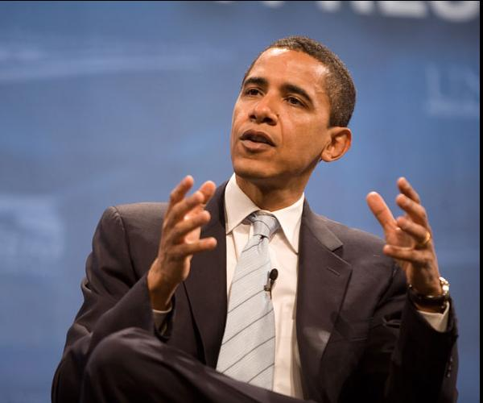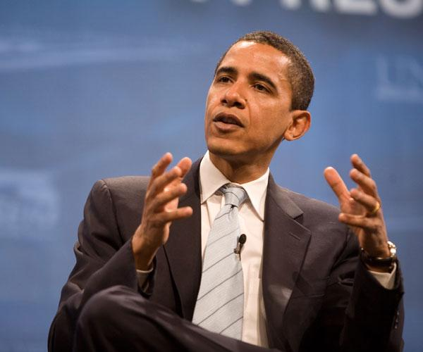

Figure 2 Translation Noise

Figure 1 Original Image

**Translation Noise with Pixel-Level Noise**

from PIL import Image

import numpy as np

def add_translation_noise(image, max_translation, noise_intensity):

width, height = image.size

# Generate random translation values

translation_x = np.random.randint(-max_translation, max_translation + 1)

translation_y = np.random.randint(-max_translation, max_translation + 1)

# Create the translation matrix

translation_matrix = (1, 0, translation_x, 0, 1, translation_y)

# Apply the translation to the image

translated_image = image.transform((width, height), Image.AFFINE, translation_matrix)

# Add pixel-level noise

noisy_image = np.array(translated_image)

noise = np.random.normal(scale=noise_intensity, size=noisy_image.shape).astype(np.int)

noisy_image = np.clip(noisy_image + noise, 0, 255).astype(np.uint8)

return Image.fromarray(noisy_image)

# Example usage

image = Image.open('/kaggle/input/image-test/test.jpg') # Load your image here

max_translation = 5 # Maximum translation in pixels

noise_intensity = 20 # Adjust the noise intensity to control the amount of visible noise

noisy_image = add_translation_noise(image, max_translation, noise_intensity)

# Save the original and noisy images

image.save('original_image3.jpg')

noisy_image.save('noisy_image3.jpg')

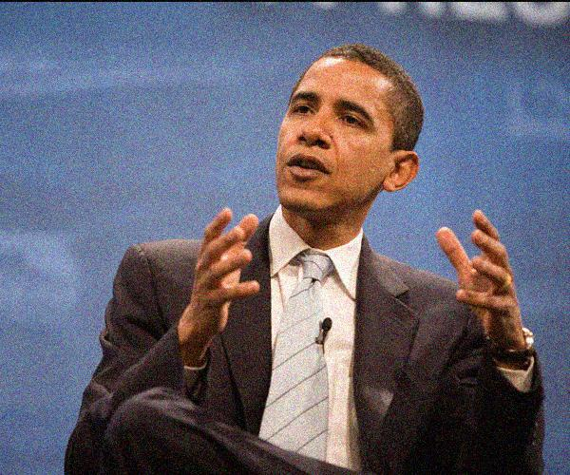

Figure : Transplation+Pixel Level Noise

Figure Orignal Image